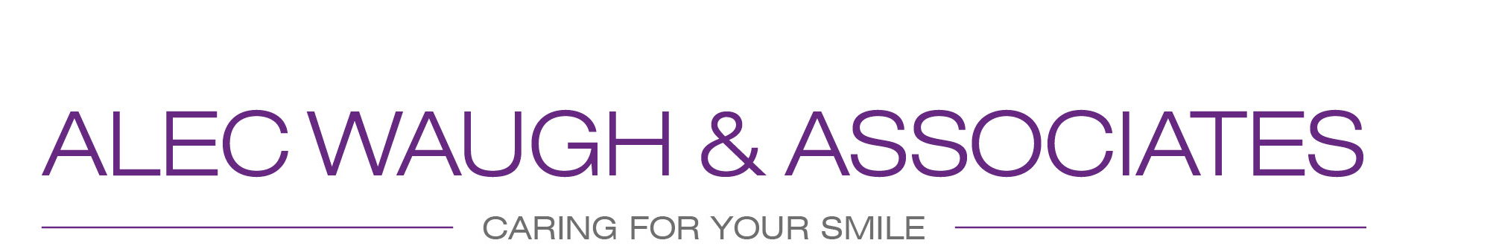
13 Jesmond Vale Terrace, Heaton, Newcastle upon Tyne, NE6 5JT Tel: 0191 2655414
Terms and Conditions

Payments
Under the terms of the NHS, full payment for all treatment is required upon seeing the dentist following your assessment or examination. All private and NHS treatment must be paid in full before commencing the treatment plan. The practice reserve the right not to book any further appointments until full payment is received. The practice reserves the right to close a treatment form should a patient cancel an appointment or fail to attend an appointment and not re-book to complete treatment. The patient will then have to pay for a new course of treatment upon their return.

Patient must attend the practice within a 2 year period or they will be removed from our NHS list

Failure to make payments within 7 days of the 1st invoice will result in a £20 charge, failure to respond or settle this payment will result in the matter being referred to our Debt Collection agents Daniels Silverman Ltd. and will be subject to a surcharge of £65 plus VAT to cover the collection costs incurred. This surcharge, together with all other charges and legal fees incurred, will be the responsibility of the patient and will be legally enforceable.

In following up any debts, we will charge for telephone calls attempted and made, letters sent, dentist and staff time spent considering the issues related to the debt, solicitors' fees, court costs, any VAT incurred, and 2.5% Monthly Interest Rate on the debt taken from the day of examination.

We are happy to accept payment in cash or by debit card and can take payment over the telephone.

Treatment must be completed within 2 months of the initial assessment or the treatment form will be closed, unless there are exceptional circumstances.

In order to maintain our commitment to NHS Dentistry, we have to work hard and continuously. When patients arrive late, cancel within 24 practice working hours of their appointment, or fail to attend, we are left with wasted time, which could have been used to help someone else and maintain the efficiency of the practice. We will issue a First warning letter to patients informing them should a further appointment be wasted no further appointments will be offered by the practice. If the second appointment is missed, a second wasted appointment letter will be issued. No further appointments will be booked following this under the NHS

Practice Plan Membership Patients & Independent Patients

Pay as you go patients or Plan Membership patients will be asked to pay for their appointment in advance, at the time of booking.
We require 24 hours notice to rebook/cancel any appointments.
Independent appointments that are missed are charged at £45 per quarter hour booked . This fee for wasted Independent time will be deducted from what you have already paid. Any monies remaining can be refunded to you, or, put towards future treatment. If there are not enough funds to cover your wasted appointment, then this fee for wasted time must be paid plus the full cost of treatment required, before any future appointments are made. Plan patients must pay back any discounts used if the plan is cancelled within 12 months of receiving the discount. Plan patients are entitled to their first free oral health check and hygiene visit 6 months after the first direct debit payment date.
Plan patients who fail to make their direct debit payments for three consecutive months will have their membership automatically cancelled, and any future appointments would be on a pay-as-you-go Independent basis.
Plan patients who do not utilise their free appointments and do not attend the Practice for over 12 months will no longer be eligible to use the World Wide Dental Scheme.
If a plan patient decides to cancel their membership, they would not be entitled to any refunds from the direct debits previously made.

GDPR Statement
Here at Alec Waugh and Associates Dental Practice we take your privacy seriously and will only use your personal information to provide you with Dental Care services, including reminding you of appointments, recording and processing all information relevant to your care and any medical conditions. All personal information is kept strictly confidential. Where necessary to provide you with the care you require we may share your information with third parties such as Dental Laboratories and the NHS BSA, Practice Plan. A list of all such third parties is available on request. When necessary should any bad debts arise, we will pass on your information to our debt collection agency.
Additionally from time to time we would like to contact you with the details of other products and services we provide.

Safeguarding Statement
We have a duty of care to all of our patient's, Adults and Children. If we feel there is a patient "At Risk" or these is cause for concern, we will liaise with the necessary Safeguarding agencies for advice -this may include your GP, and other Health and Social Care services.

By signing these Terms and Conditions, I acknowledge that I understand and will abide by the above conditions.
These Terms and Conditions supersede any previous.

